

Internet of things PROJECTS/INTERNSHIP

# College Name

* ****SRM Institute of Science and Technology.****

# Company Name

* ****Vyorius.****

# Domain

* ****Internet of things.****

### Internship Project topics

1. **Automatic Room Temperature Controller**
2. **Voice Control Home Automation**

1. Automatic Room Temperature Controller

Software's In detail



* Tinkercad is a free online collection of software tools that help people all over the world think, create and make. We’re the ideal introduction to Autodesk, the leader in 3D design, engineering and entertainment software.

Hardware In detail

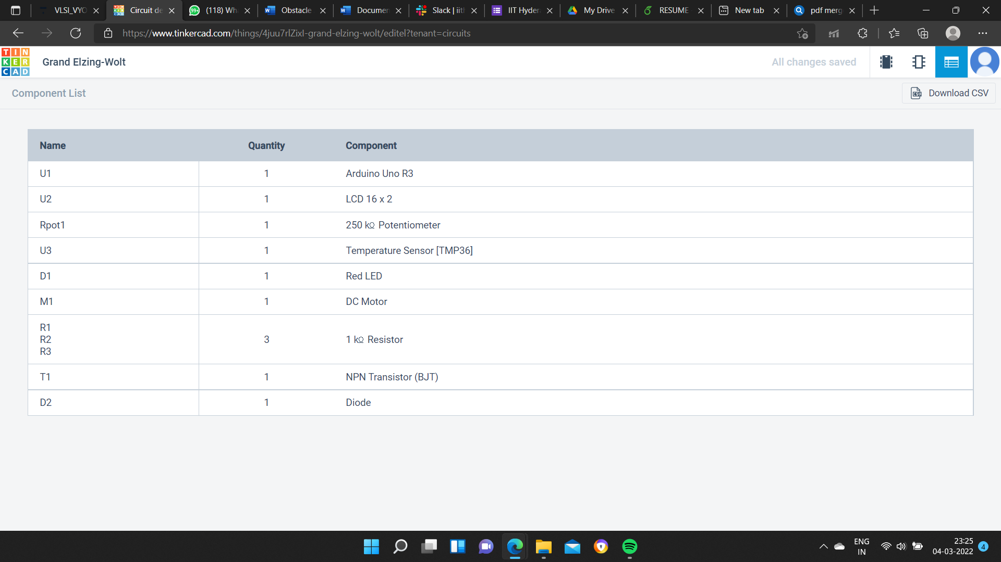

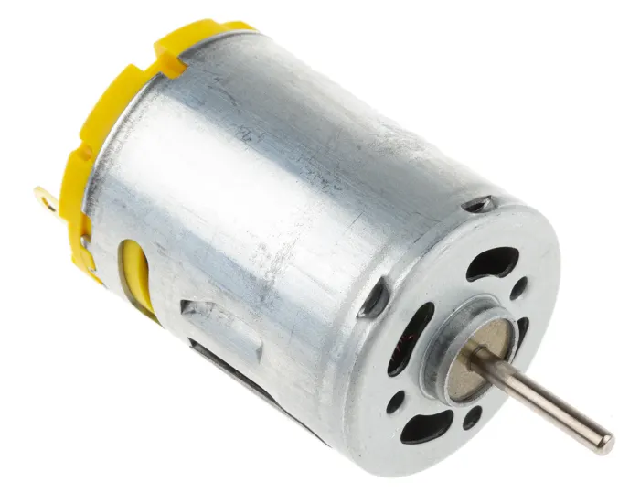

**DC motors.**

A Direct Current (DC) motor is **a motor that turns energy from a direct current and turns this into mechanical energy**. The first DC motor was developed around the 1830's-1840s. They were commercially unsuccessful, because these motors were battery powered and batteries were still very expensive and the quality was low.

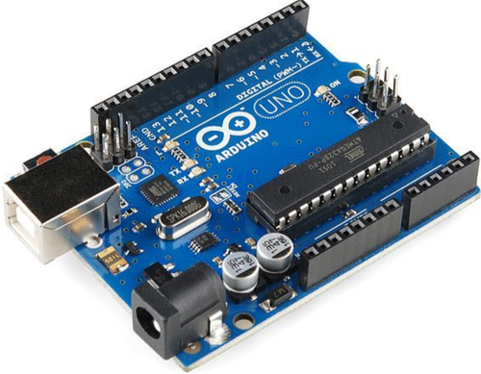

**ATmega328P**

ATmega328P is a **high performance yet low power consumption 8-bit AVR microcontroller** that's able to achieve the most single clock cycle execution of 131 powerful instructions thanks to its advanced RISC architecture. It can commonly be found as a processor in Arduino boards such as Arduino Fio and Arduino Uno.

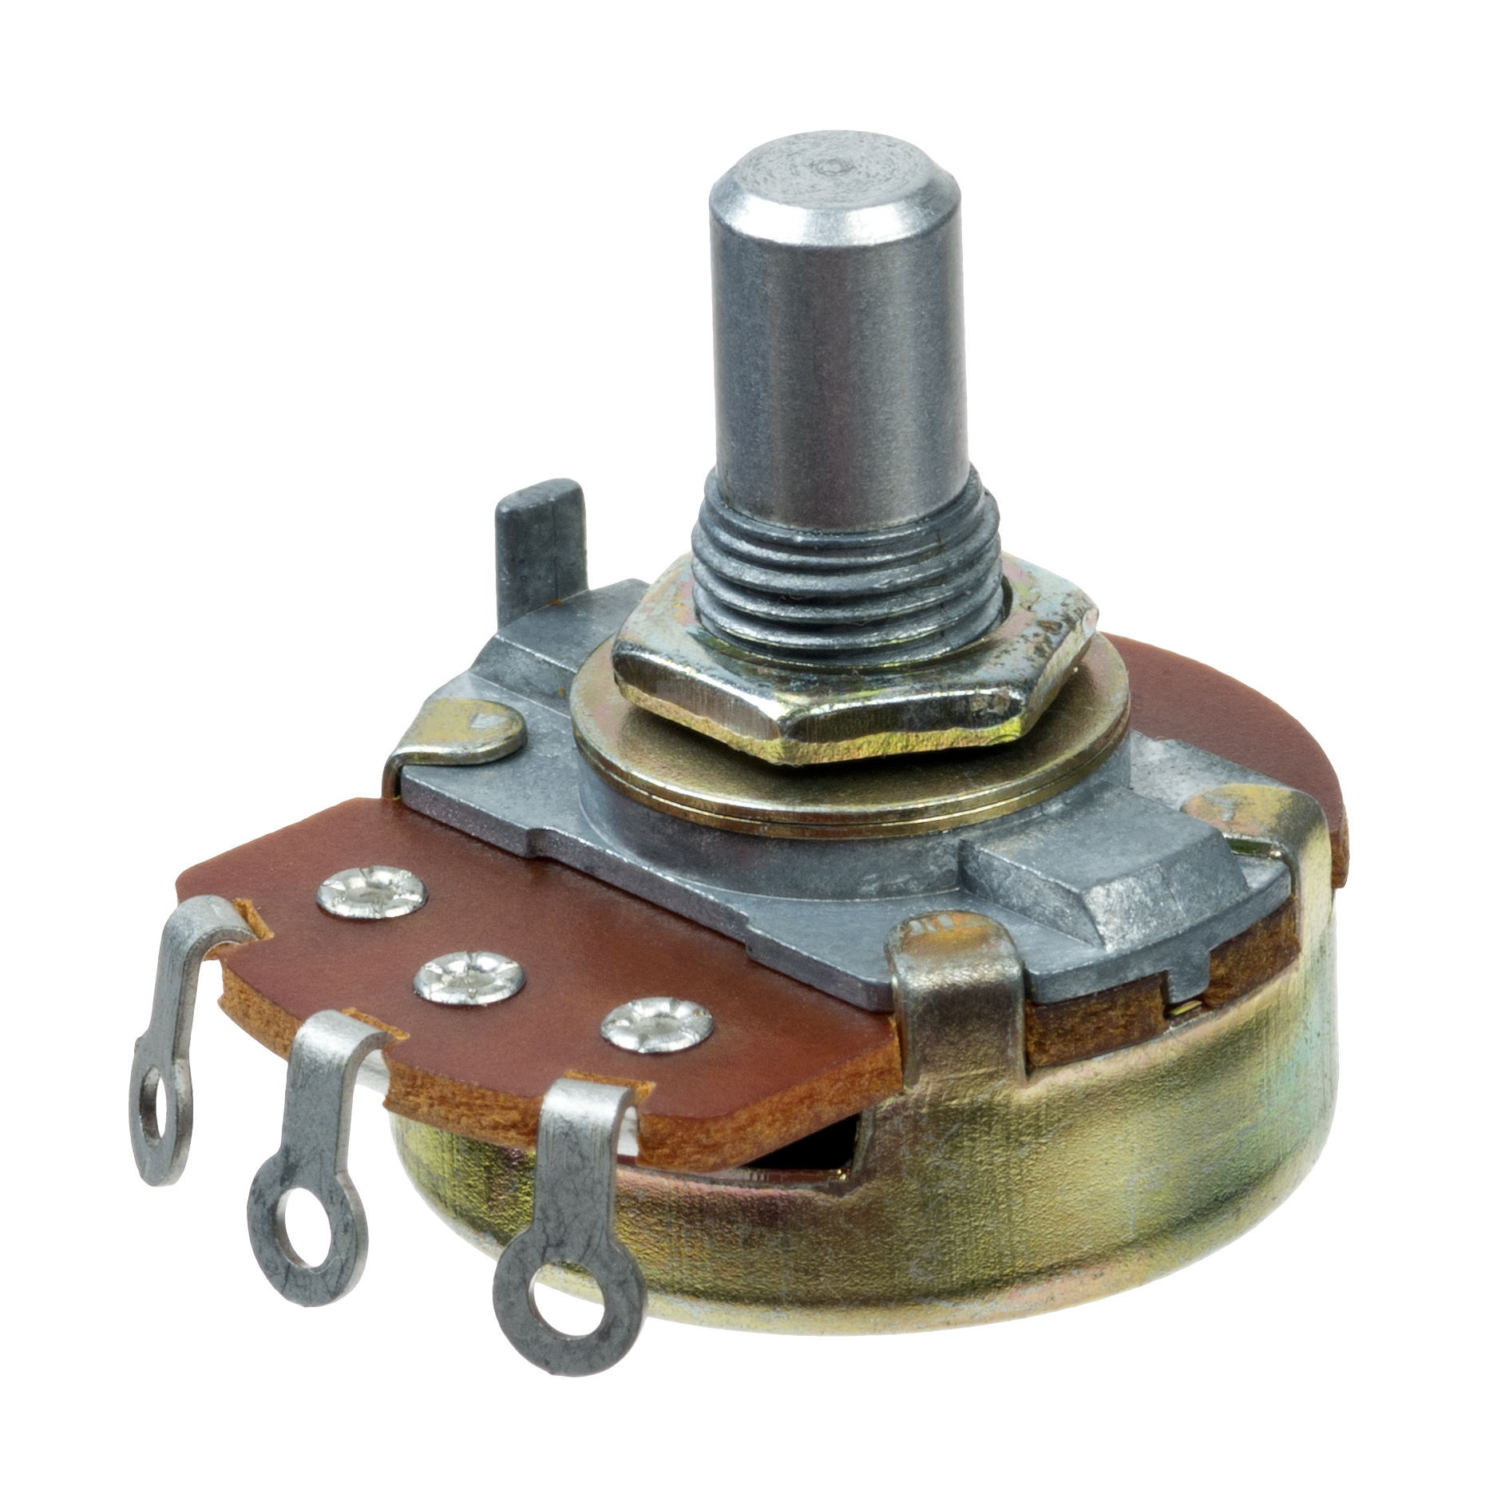

**Potentiometer**

A potentiometer is a type of position sensor. They are used **to measure displacement in any direction**. Linear potentiometers linearly measure displacement and rotary potentiometers measure rotational displacement.

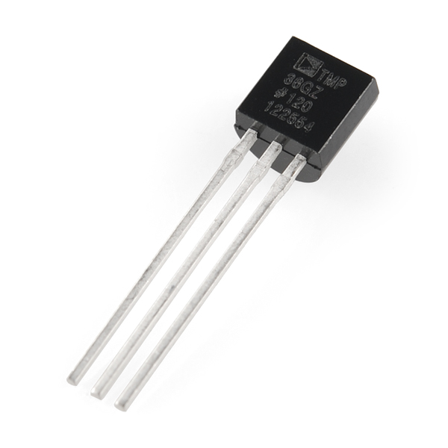

**Temperature sensor**

A temperature sensor is **a device used to measure temperature**. This can be air temperature, liquid temperature or the temperature of solid matter. There are different types of temperature sensors available and they each use different technologies and principles to take the temperature measurement.

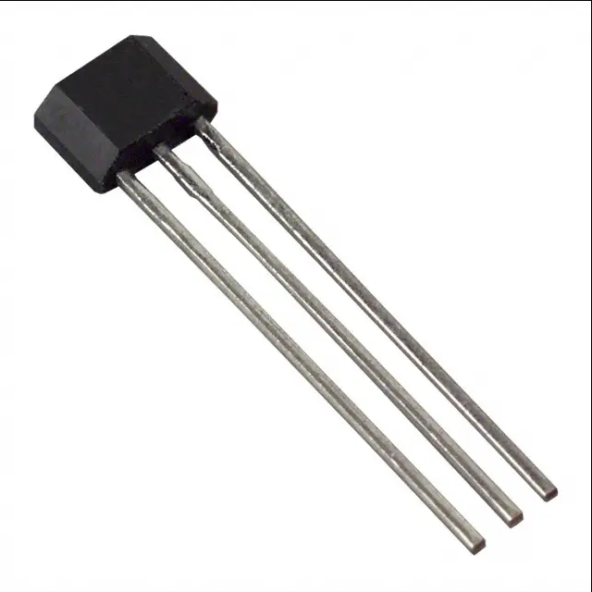

**NPN Transistor (BJT)**

NPN Transistors are **three-terminal, three-layer devices that can function as either amplifiers or electronic switches**. In the previous tutorial we saw that the standard Bipolar Transistor or BJT, comes in two basic forms. An NPN (Negative-Positive-Negative) type and a PNP (Positive-Negative-Positive) type.

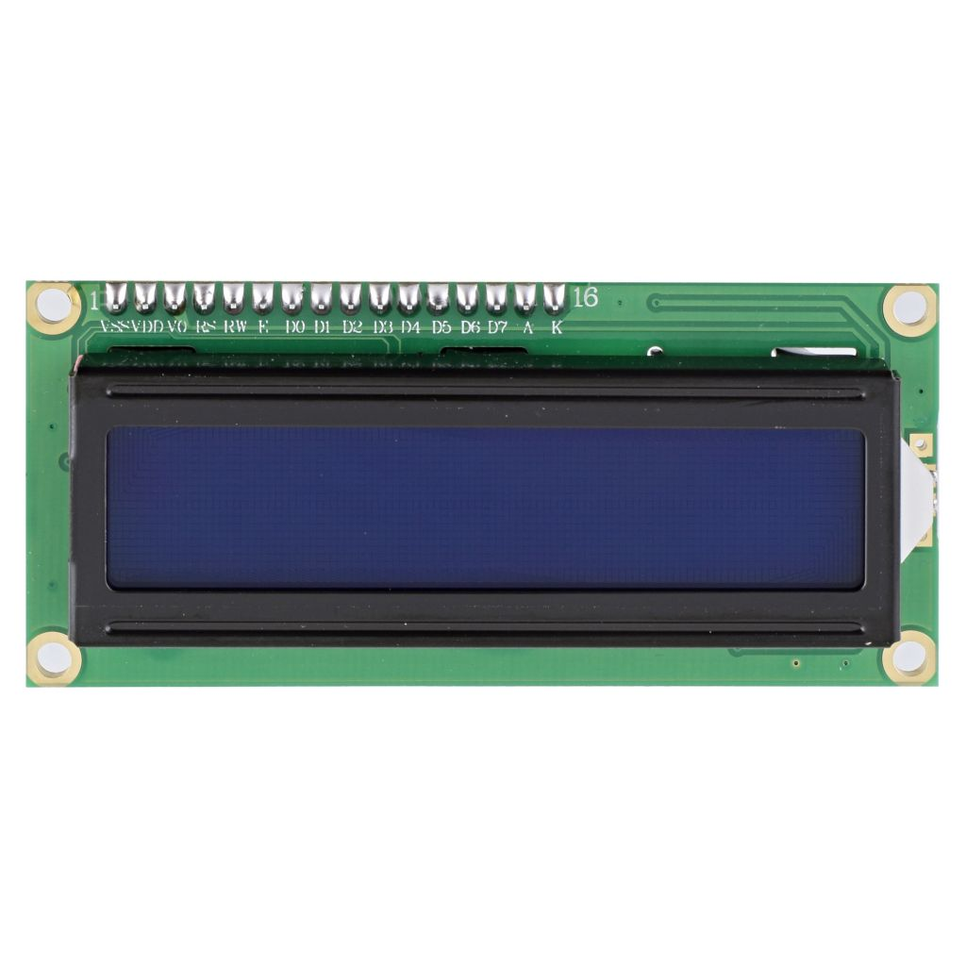

**LCD**

LCD (Liquid Crystal Display) is **a type of flat panel display which uses liquid crystals in its primary form of operation**. LEDs have a large and varying set of use cases for consumers and businesses, as they can be commonly found in smartphones, televisions, computer monitors and instrument panels.

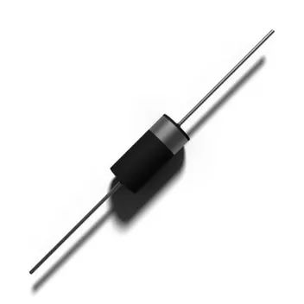

**Diode**

A diode is a semiconductor device that essentially **acts as a one-way switch for current**. It allows current to flow easily in one direction, but severely restricts current from flowing in the opposite direction.

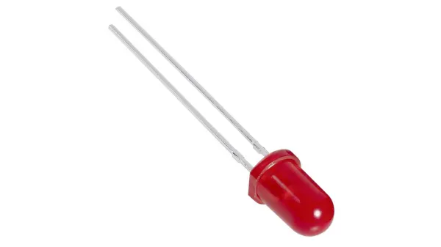

**LED**

LEDs (Light Emitting Diodes) are the latest development in the lighting industry. Made popular by their efficiency, range of color, and long lifespan, LED lights are ideal for numerous applications, including **night lighting, art lighting, and outdoor lighting**.

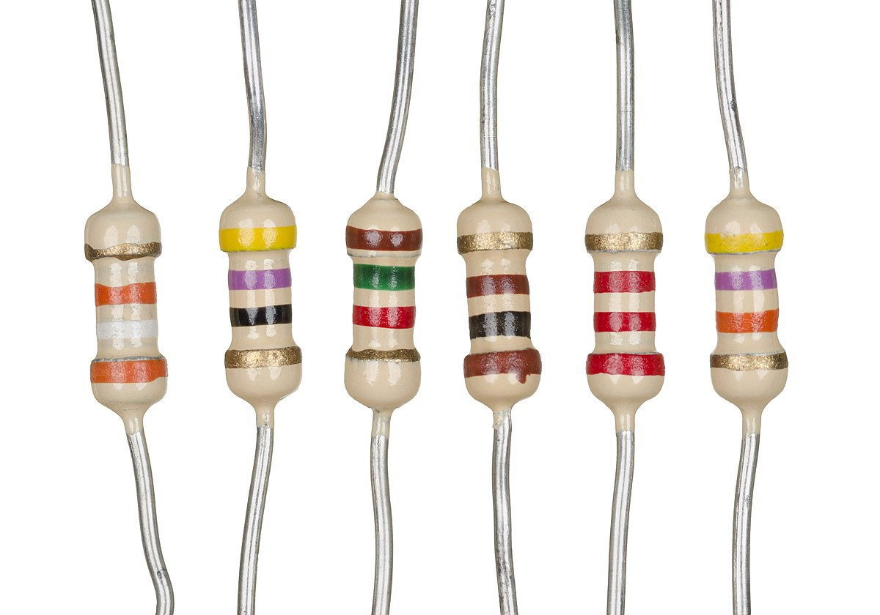

**Resistors**

A resistor is a passive electrical component with the primary function to **limit the flow of electric current**.



**Jump wire**

A jump wire (also known as jumper, jumper wire, jumper cable, DuPont wire or cable) is an electrical wire, or group of them in a cable, with a connector or pin at each end (or sometimes without them – simply "tinned"), which is normally used to interconnect the components of a breadboard or other prototype or test.

**TINKERCAD CIRCUIT OVERVIEW**

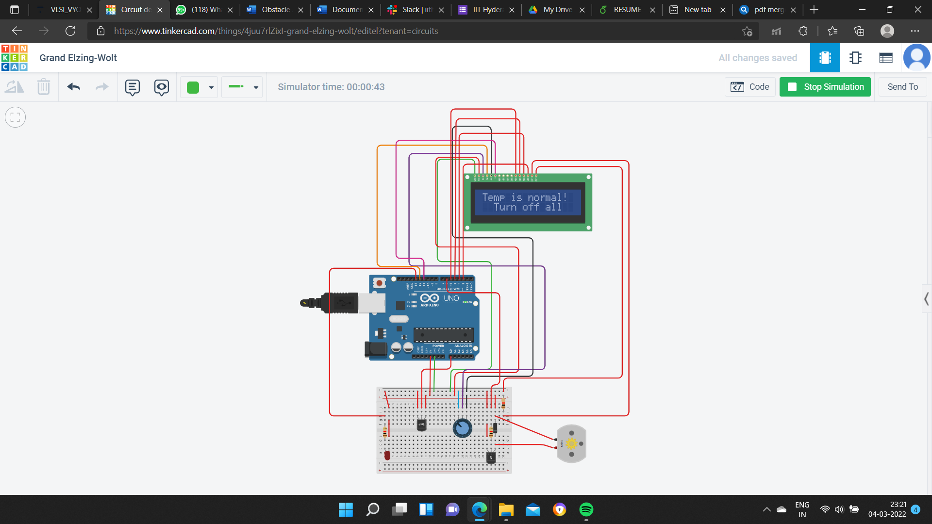

**CODE**

const int temp_trans_pin=A0;

const int Heater_pin=13;

const int FAN_pin= 6;

//Set the range of the desire temperature

float MinTemp=20, MaxTemp=25; //Room Temp (20-25)

#include<LiquidCrystal.h>

LiquidCrystal LCD (12, 11, 5, 4, 3, 2);

void setup () {

LCD.begin(16,2);

pinMode(Heater_pin, OUTPUT);

pinMode (FAN_pin, OUTPUT) ;

LCD.print ("Room Temp(C) : ");

LCD. setCursor(2,1);

LCD.print (MinTemp); LCD.print("-"); LCD.print(MaxTemp);

delay (2000);

}

void loop() {

float Egv_volt, SensorTemp;

Egv_volt=analogRead (temp_trans_pin)*5.0/1023;

SensorTemp=100.0*Egv_volt-50.0;

LCD.clear();

LCD. print ("Sensor Reading: ");

LCD.setCursor(2, 1);

LCD.print(SensorTemp);

LCD.print(" C");

delay(2000);

if (SensorTemp>MaxTemp){

LCD.clear();

LCD.print ("Temp is HIGHER!");

LCD.setCursor (0,1);

LCD.print ("Turn on FAN!");

for(int i=0; i<=255; i++){

analogWrite (FAN_pin,i);

}

delay(2000) ;

LCD.clear();

LCD.print("Now Temp is OK!");

LCD.setCursor(0,1);

LCD.print("Turn Off FAN!");

for (int i=255; i>=0; i--){

analogWrite (FAN_pin, i);

}

delay(2000) ;

}

else if (SensorTemp<MinTemp){

LCD.clear();

LCD.print ("Temp is LOWER!") ;

LCD.setCursor (0, 1) ;

LCD.print ("Turn on HEATER!") ;

digitalWrite(Heater_pin, HIGH) ;

delay(3000);

LCD.clear();

LCD.print ("Temp is OR!") ;

LCD.setCursor (0, 1) ;

LCD.print ("Turn off HEATER!") ;

digitalWrite(Heater_pin, LOW) ;

LCD.clear();

}

else if (SensorTemp>MinTemp && SensorTemp<MaxTemp){

LCD.clear();

LCD.print ("Temp is normal!") ;

LCD.setCursor (2, 1) ;

LCD.print ("Turn off all") ;

delay(1000);

LCD.clear();

}

else {

LCD.clear();

LCD.print ("Something went wrong") ;

LCD.setCursor (2, 1) ;

LCD.print ("Wrong in the circuit") ;

delay(1000);

LCD.clear();

}

delay(1000);

}

}

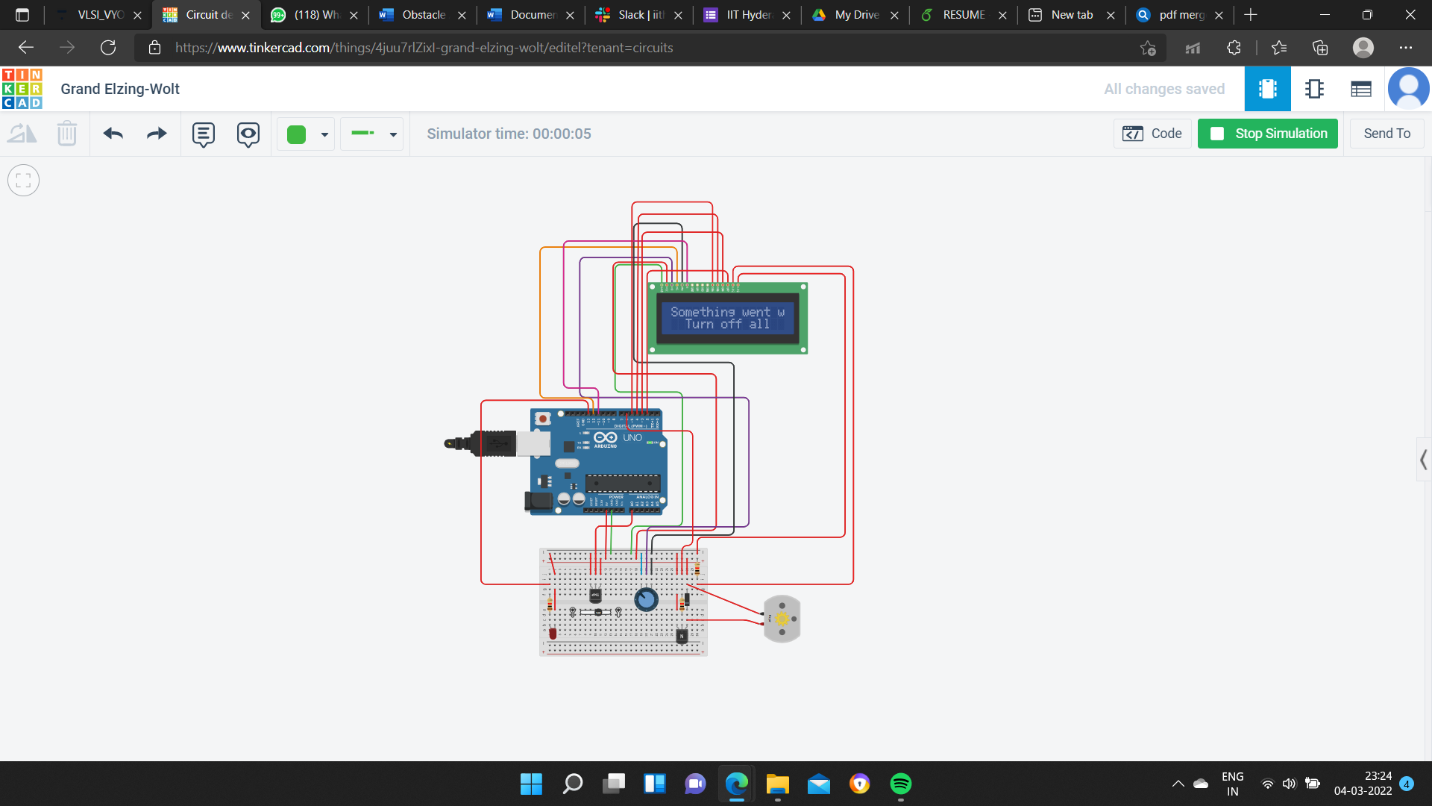

**Conclusion**

Our project is aimed at starting one ac among both depending upon the temperature value at a particular room. If the temperature on the particular room is above certain range, then the AC in that room will start up and during this time the AC in the other room will remain switched off. When the temperature goes below 25 degrees in the room where AC is already on will be switched off automatically. Then if the temperature on the other room during the time is above 30degree then the AC in that room will start up and vice versa. The second feature of our project is aimed at switching of the AC automatically when there is absence of human beings in a particular room. This project will solve the day-to-day problem where AC’s do not start up due to low voltage generally in rural areas. This will start the AC depending upon the temperature label in a room by sharing the load. Also, this project can be extended for controlling the temperature in more rooms in an apartment.